CLASSIFICATION TREE
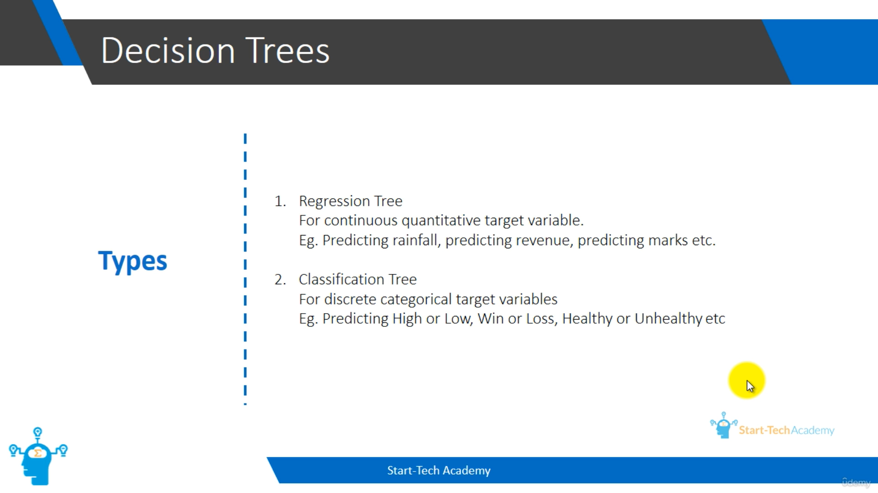
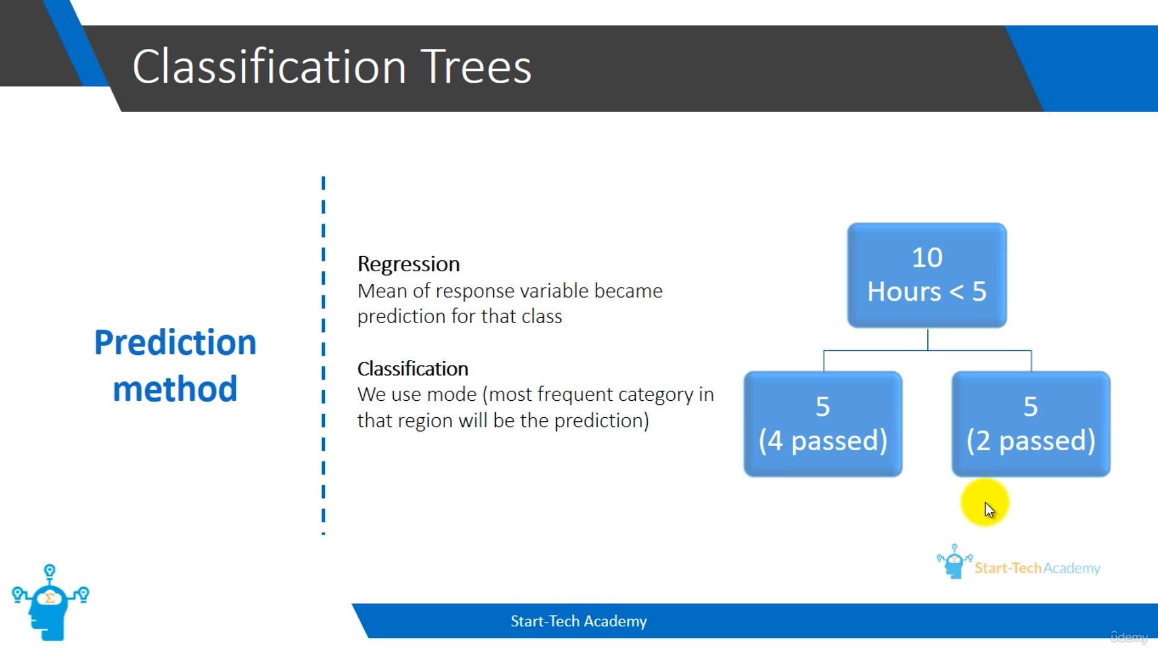
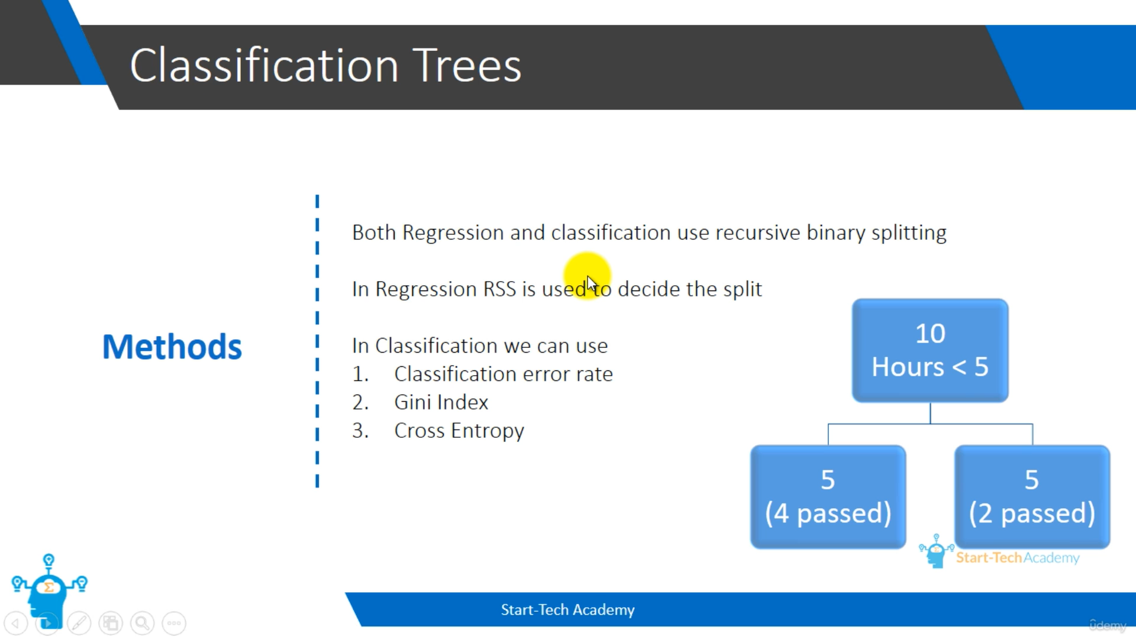
Classification Error Rate – In the above split, we can see that 1 failed person doesn’t involve in the first split and 2 passed person doesn’t involve in the second split. So out of 10 students, 3 were predicted wrong or splitted wrong. So the classification error rate is 30%. If a split has minimum classification error rate, we will consider that split.
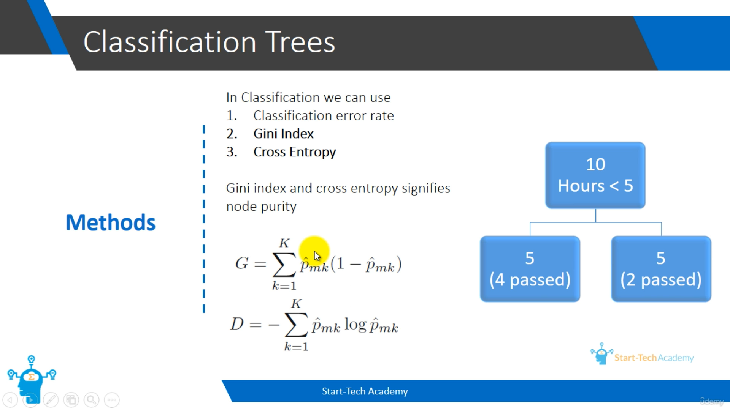
Gini index and Cross entropy are similar. Both signify node purity. If node purity is high we can keep the split. Here Pmk represents the probability of the pass/fail at a particular region or a node. If a probability is either 0 or 1, then the node is very pure. Likewise for the cross entropy as well.
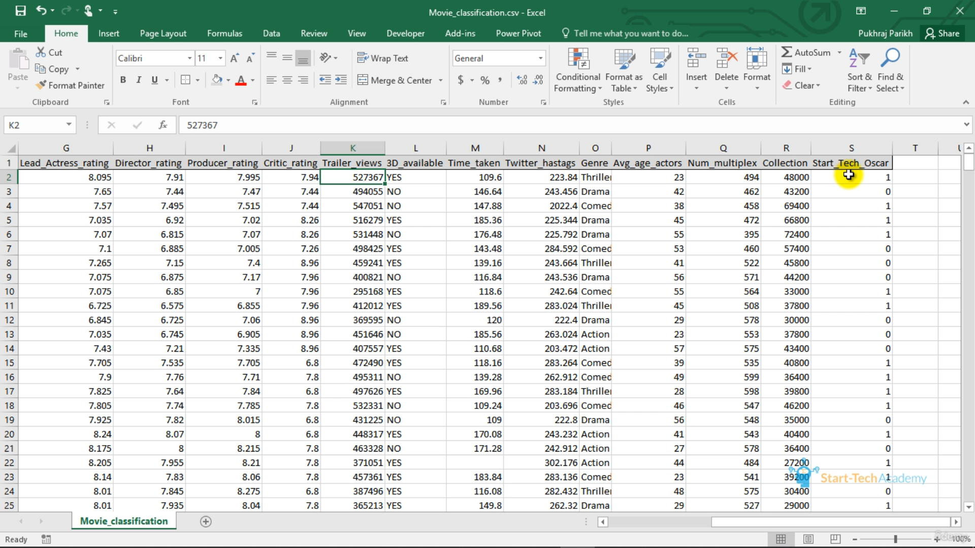
We now, classify that a movie win an Oscar or not. So, we use Classification Tree.

